https://www.jdoodle.com/embed/v0/6bwT
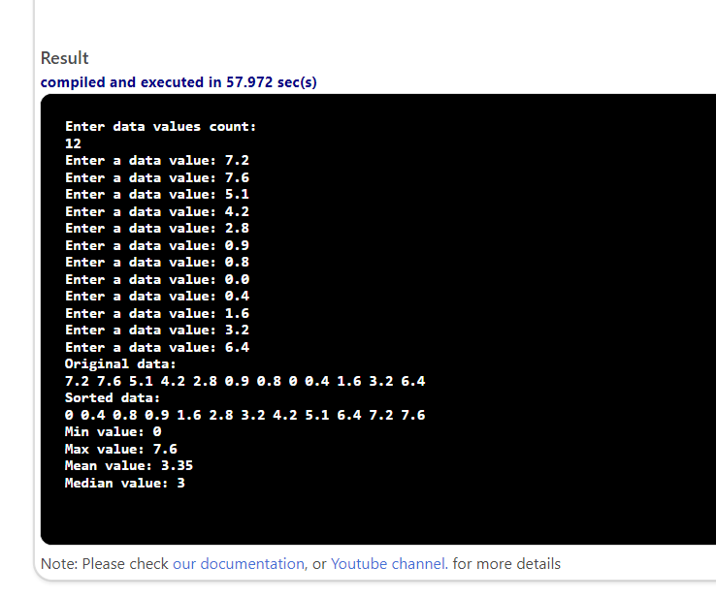
#include <iostream>
using namespace std;

void input(double data[], int dataLength);
void copy(double data[], double sdata[], int dataLength);
void sort(double sdata[], int dataLength);
double findMin(double sdata[], int dataLength);
double findMax(double sdata[], int dataLength);
double findMean(double sdata[], int dataLength);
double findMedian(double sdata[], int dataLength);
void display(double data[], int dataLength);

int main()
{
int dataLength;
double data[20];
double sdata[20];

cout << "Enter data values count: " << endl;
cin >> dataLength;

input(data, dataLength);

copy(data, sdata, dataLength);
sort(sdata, dataLength);

double min = findMin(sdata, dataLength);
double max = findMax(sdata, dataLength);
double mean = findMean(sdata, dataLength);
double median = findMedian(sdata, dataLength);

cout << "Original data: " << endl;
display(data, dataLength);

cout << "Sorted data: " << endl;
display(sdata, dataLength);

cout << "Min value: " << min << endl;
cout << "Max value: " << max << endl;
cout << "Mean value: " << mean << endl;
cout << "Median value: " << median << endl;

return 0;
}

void input(double data[], int dataLength)
{
for (int i = 0; i < dataLength; i++)
{
cout << "Enter a data value: ";
cin >> data[i];
}
}

void copy(double data[], double sdata[], int dataLength)
{
for (int i = 0; i < dataLength; i++)
{
sdata[i] = data[i];
}
}

void sort(double sdata[], int dataLength)
{
for (int i = 0; i < dataLength - 1; i++)
{
for (int j = 0; j < dataLength - i - 1; j++)
{
if (sdata[j] > sdata[j + 1])
{
double temp = sdata[j];
sdata[j] = sdata[j + 1];
sdata[j + 1] = temp;
}
}
}
}

double findMin(double sdata[], int dataLength)
{
return sdata[0];
}

double findMax(double sdata[], int dataLength)
{
return sdata[dataLength - 1];
}

double findMean(double sdata[], int dataLength)
{
double sum = 0;
for (int i = 0; i < dataLength; i++)

{
sum += sdata[i];
}
return sum / dataLength;
}

double findMedian(double sdata[], int dataLength)
{
double median;
if (dataLength % 2 == 0)

{
median = (sdata[dataLength / 2 - 1] + sdata[dataLength / 2]) / 2;
}
else

{
median = sdata[dataLength / 2];
}

return median;
}

void display(double data[], int dataLength)
{
for (int i = 0; i < dataLength; i++)
{
cout << data[i] << " ";
}
cout << endl;
}

